“”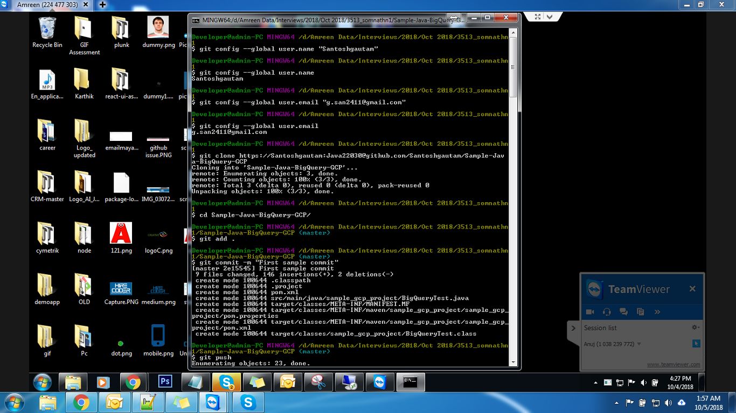

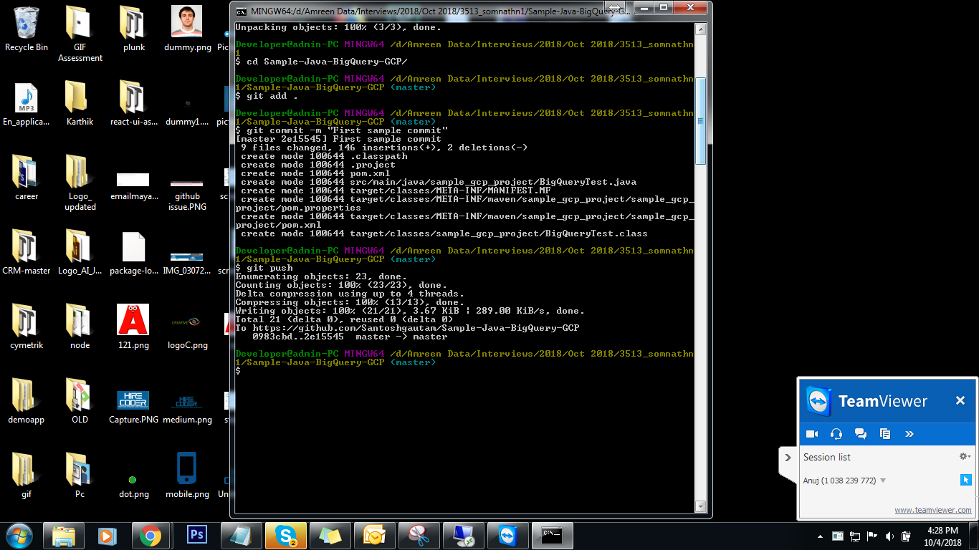

https://confluence.atlassian.com/bitbucketserver/basic-git-commands-776639767.html